

Proposal Report

by

<Team name>

Feb 2024

<Indian Insititute of Information Technology Kottayam>

**Table of Contents**

# Instructions

In your final version of the proposal report, please eliminate this page along with its template fields and text. Any text slated for removal is highlighted in light blue. Adhere to the template's section order, and while the suggested section sizes are based on their importance to the overall challenge, feel free to adjust as needed. The descriptive text accompanying each section is provided as guidance and should be substituted with your own content. The tables contain essential information, and although it is recommended to maintain their current format, doing so is not mandatory. This page consolidates all proposal-related requirements for your convenience.

**You can modify this template to improve its graphical appearance.**

# Before you start

Compose the Proposal Report (PR) only after thoroughly understanding the challenge requirements and constraints outlined in the preliminary rule book. This requires the team's ability to formulate a proposal that fulfils the specified requirements. In the initial phase of system design, teams create a baseline design for the entire system. Therefore, it's crucial for teams to meticulously review the preliminary rules and ensure no requirement or constraint is overlooked. Additionally, the document should incorporate project management strategies to achieve the goal within the allocated time-frame.

Document Requirements:

* First page: Follow the provided template.
* Format: A4 size, PDF format with search capability.
* Length: Up to 30 pages, including the title page and lists of contents, figures, and tables.
* File size: Maximum 10 MB.
* Language: English.
* Appendices: None.
* Use a minimum font size of 10, with margins of at least 2.54 cm (1 inch) from all page edges (set to 'Normal' in MS Word).
* Include a presentation summarizing the proposal, limited to 15 slides and 5 MB.

The proposal should encompass the following information:

* System architecture aligned with challenge requirements.
* Explanation of the roving mechanism.
* Description of the sample pick-and-place mechanism.
* Overview of the emergency response system.
* Identification of hardware (mechanical, electrical, electronic, optics, etc.) based on the system architecture.
* Define the software development requirements using an algorithm.
* Outline the plan for hardware and software implementation.
* Develop a plan for testing and validation.
* Brief of system specification.
* Highlight the originality within the entire proposal.
* Present the project management approach and timeline.
* Include any other relevant information.

**Proposal scoring methodology**

|  |  |  |  |
| --- | --- | --- | --- |
| **No.** | **Evaluated Parameter** | **Maximum Score** | **Description of evaluated parameter** |
| 1 | System Architecture | 10 | * Illustration of the system architecture through a diagram. * Identification of interfaces among different sub-systems. * Inclusion of all essential sub-systems required in the system architecture. |
| 2 | Roving Mechanism | 10 | * Schematic representation of the roving mechanism. * Comprehensive understanding of the chosen mechanism. * Explanation for selecting the proposed mechanism. |
| 3 | Mechanism for Sample Pick-and-Place Activity | 5 | * Schematic representation of the chosen mechanism. * Thorough understanding of the selected mechanism. * Justification for selecting the proposed mechanism. |
| 4 | Emergency Response System | 5 | * Identification of emergency situations. * Description of the Response System. |
| 5 | Hardware Identification | 10 | * Sub-system-wise list of all required hardware for realizing the overall system. * Justification for selecting the type of hardware. * Estimated Bill of Material (BoM) for the system. |
| 6 | Software Identification | 10 | * Identification of software requirements for operating the realized system. * Algorithm selection for various computation tasks. |
| 7 | Hardware and Software Realization Plan | 10 | * Categorization of identified hardware into various sources of realization. * Specifications for purchased hardware. * Realization plans for fabricated hardware. * Implementation strategies for software. |
| 8 | Test Plan | 10 | * Identification of required tests. * Test plans for all identified tests. |
| 9 | System Specifications | 5 | * Generate table of specification for the proposed system |
| 10 | Project Management | 5 | * Identification of responsibilities among team members with a system breakdown structure. * Strategy for schedule management. * Cost estimation. |
| 11 | Novelty in the overall proposal | 10 | * Originality in terms of system design, hardware/software selection, etc. |
| 12 | Any Other Relevant Information | 0 | * Teams can include any additional information deemed necessary in the proposal. |
| 13 | Presentation | 10 | * Presentation file |
| 14 | Non-compliant Documentation Format | -20 as penalty | Example of non-compliance:   * Small font or margin * Exceeding the report length * Plagiarism exceeding 40% |
| Total | | 100 | Maximum Score |

System Architecture

Provide system architecture for the rover that aligns with the task requirements. Enumerate all the necessary sub-systems for the task, outlining their interdependencies and interface requirements. It is recommended to convey this information through a system architecture diagram. Below is an illustrative example of helicopter system architecture for reference

Tasks the Robot Achive :

- 1. To deliver the food and water and Medicinal pacakages to people who need.

- 2. To autonomously navigate to the location given.

- 3. To identifes any Human in danger and report the location .

- 4. To avoid obstacles and self-control or balace it self from water waves.

**Task Requirement :**

1. **To Avoid Obstacles andd Self-Control or Balacning of Robot** :

**Requirement :**

1. **To Autonomously Navigate and To Localizse itself in the terrain:**

**Requirement** : If you're already using LoRaWAN (Long Range Wide Area Network) for communication between your GPS devices, that's a viable and efficient solution. LoRaWAN is a low-power, wide-area networking protocol designed for long-range communication with low data rates. It's well-suited for applications where devices need to transmit small amounts of data over relatively long distances.

Here's how you can use LoRaWAN for transmitting location information between GPS devices:

1. *LoRaWAN Devices:*

- Ensure that both GPS devices are equipped with LoRaWAN modules. These modules typically include a LoRa radio for long-range communication and a microcontroller for processing and encoding data.

### 2. *Integration with GPS Module:*

- Integrate the LoRaWAN module with the GPS module on each device. This involves reading the GPS coordinates from the GPS module and encoding the location data for transmission.

### 3. *LoRaWAN Gateway:*

- Set up one or more LoRaWAN gateways in the vicinity. These gateways act as intermediaries between the LoRaWAN devices and the network server.

### 4. *Network Server:*

- Connect the LoRaWAN gateways to a LoRaWAN network server. The network server manages the communication between devices and the application server.

### 5. *Application Server:*

- Implement an application server that receives the location data from the LoRaWAN network server. This server processes and stores the data, and it can also send commands back to the devices if needed.

### 6. *Data Transmission:*

- Develop the firmware on each GPS device to periodically transmit location data over the LoRaWAN network to the application server. The transmission interval and payload format can be configured based on your requirements.

### 7. *Security:*

- LoRaWAN includes built-in security features. Ensure that your implementation follows best practices for securing communications, including device authentication and encryption.

### 8. *Power Considerations:*

- LoRaWAN is known for its low-power characteristics. Take advantage of this by optimizing power consumption in your device firmware to extend battery life.

### 9. *Geolocation Services (Optional):*

- If precise GPS coordinates are not needed, you can use LoRaWAN geolocation services to estimate a device's location based on the signals received by multiple gateways. This is especially useful in scenarios where GPS signals may be obstructed.

### 10. *Regulatory Compliance:*

- Ensure that your use of LoRaWAN complies with local regulations and frequency allocations. Different regions may have specific guidelines for the use of LoRaWAN.

By leveraging LoRaWAN, you can achieve long-range communication between devices without relying on cellular networks or the internet. This is particularly useful in scenarios where devices are deployed in remote areas or where cellular coverage is limited. Additionally, LoRaWAN's low-power characteristics make it suitable for battery-powered devices that need to operate for extended periods.

1. **To identify Human Being in Help and Danger . To geo Tag dangerous and Hazards Routes**.

**Requirements :** Telescopic camer with Movering ~ Computer Vision (Camera) , Micro-Controller . GPS Navigation Unit and Communication System .

Frist the After the Power is Turned on the ROS will give intrustions to check the Fault and Diagooistic System after checking the Communication , Navigation and guidance and Vision system are activated and data is feed to the ROS. After Thruster System is Activated and Robot moves.

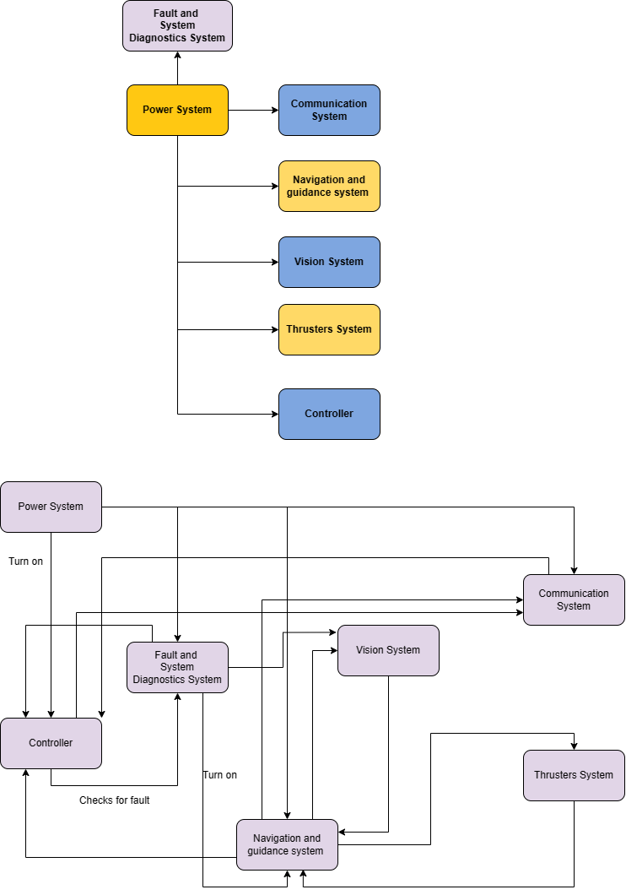

**(Note: The example is provided for reference and does not need to be followed in the same format).**

1. **Communication System**
2. **Thruster System**
3. **Power system**
4. **Fault Tolerant and error checking system**
5. **Navigation and guidance system**
6. **Controller**
7. **Vision system -- > Camera**

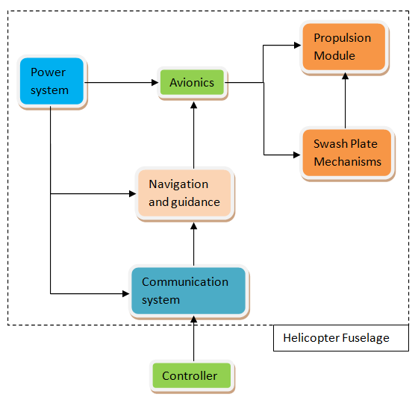

Criteria for Assessment:

* Illustration of the system architecture through a diagram.
* Identification of interfaces among different sub-systems.
* Inclusion of all essential sub-systems required in the system architecture.

**<Suggested length: 2-3 pages>**

Roving Mechanism in Water

Thruster Design :

Existing Solution :

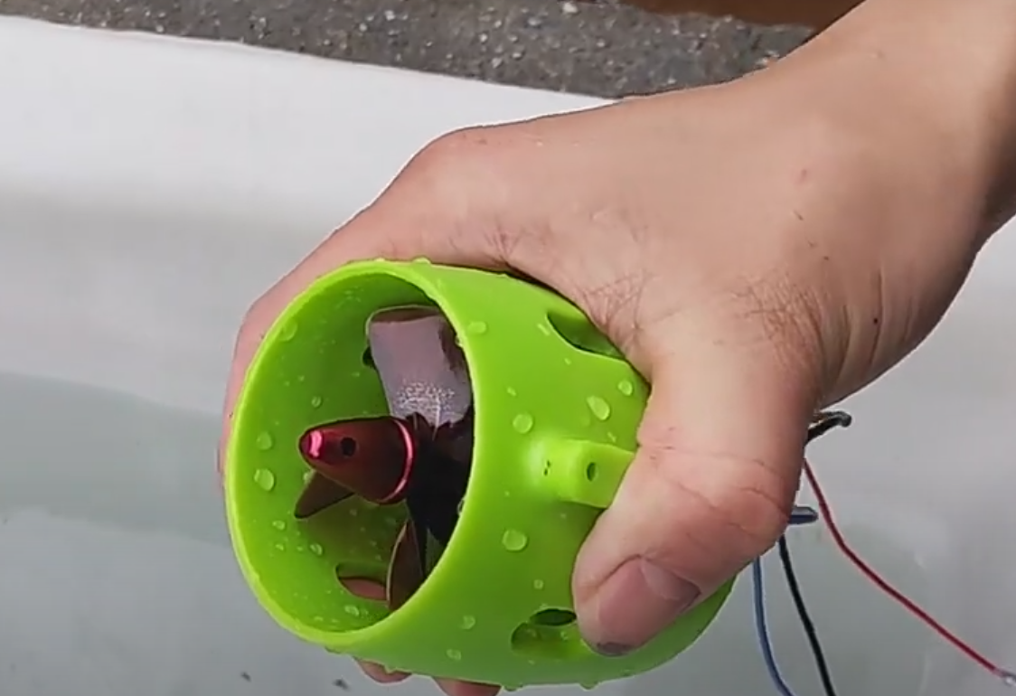

Link : <https://youtu.be/1ks3UfGmZGo?si=acjaaPBGWzqczSEt>

1. 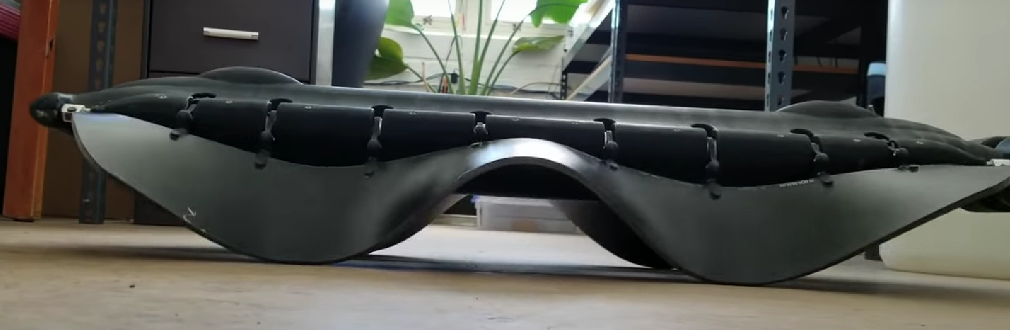

Link : <https://youtu.be/CkZszsl2aIU?si=qmMh_UrWt1ZVZlE_>

1. 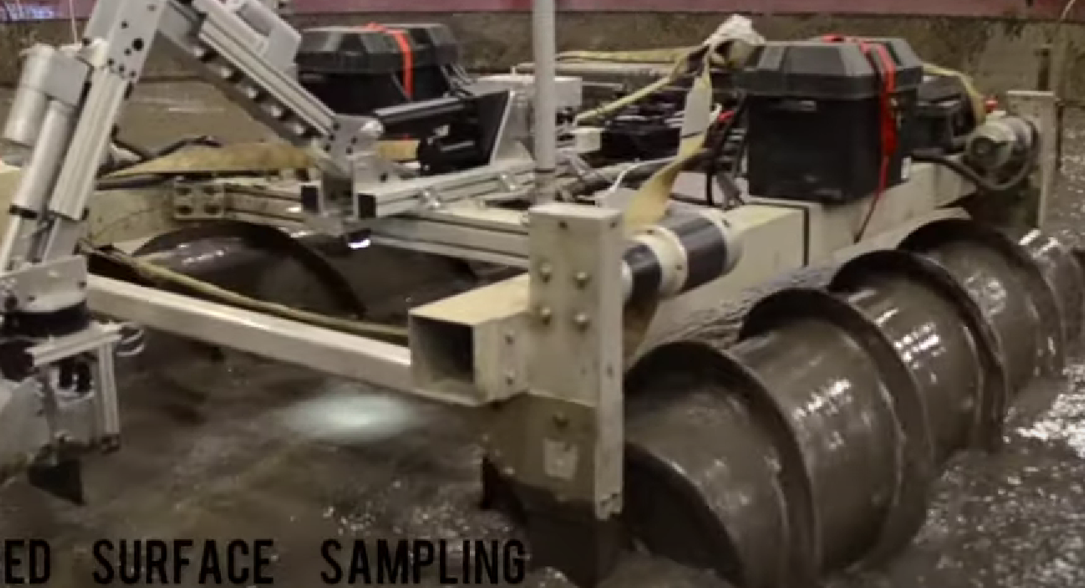
2. 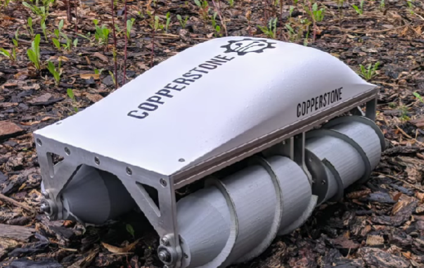

Link : <https://youtu.be/HskkF7c_Hvc?si=jO7uqg74ZdFikrEv>

1. 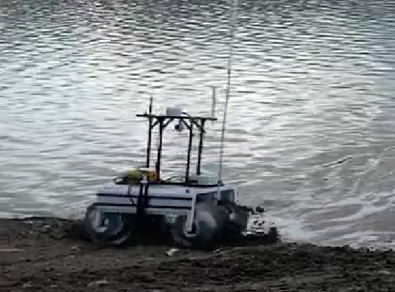

Link : <https://youtu.be/uxysAthPLgc?si=o6e0szex5cldAAv6>



1. <https://youtu.be/kG8J6H5C0Ik?si=sN_rorph8cDYluzc>

Provide a concise overview of the roving mechanism, accompanied by a schematic. Compare various potential options and justify the selection of the chosen mechanism.

Criteria for Assessment:

* Schematic representation of the roving mechanism.
* Comprehensive understanding of the chosen mechanism.
* Explanation for selecting the proposed mechanism.

**<Suggested length: 1-2 pages>**

Mechanism for Sample Pick-and-Place Activity

There is a Dedicated Space for the payload to be kept (Food and Medicei , Water ) After the Pacakeg is loaded into the Space Lid is closed air tight and bot is navigated.After reaching the Destination the people will open the lid and take pacage.

Offer a concise description of the sample picking and placing mechanism, accompanied by a schematic. Compare different potential options and provide the rationale for selecting the specific mechanism.

Criteria for Assessment:

* Schematic representation of the chosen mechanism.
* Thorough understanding of the selected mechanism.
* Justification for selecting the proposed mechanism.

**<Suggested length: 1-2 pages>**

Emergency Response System

Potential Emergency :

Identify potential emergency situations anticipated during task execution. Present a system designed to address these situations, providing a brief explanation of its working principle. Additionally, consider including alternative emergency response systems, along with the rationale for choosing the proposed one.

Criteria for Assessment:

* Identification of emergency situations.
* Description of the Response System.

**<Suggested length: 1-2 pages>**

Hardware identification

Using the presented system architecture as a basis, the team should determine the necessary hardware to bring the overall system to fruition. Teams must make decisions regarding the type of hardware, accompanied by an explanation for choosing a specific hardware type. It is preferable for the team to present the hardware requirements in a tabular format, akin to the provided example **(Note: The example below is provided for reference and does not need to be followed in the same format).**

|  |  |  |  |  |  |
| --- | --- | --- | --- | --- | --- |
| No. | Hardware Details | Subsystem | Category | Quantity Needed | Justification for Chosen Type |
| 1 | Motor | Roving Mechanism | Stepper Motor | 6 | Ease of control Availability |
|  |  |  |  |  |  |
|  |  |  |  |  |  |
|  |  |  |  |  |  |
|  |  |  |  |  |  |
|  |  |  |  |  |  |
|  |  |  |  |  |  |

Criteria for Assessment:

* Sub-system-wise list of all required hardware for realizing the overall system.
* Justification for selecting the type of hardware.
* Estimated Bill of Material (BoM) for the system.

**<Suggested length: 2-3 pages>**

Software identification

Teams are required to recognize the necessary software for task execution using the realized hardware. Provide a brief description of the algorithm and development environment intended for the identified software. If there are plans to utilize any software directly from open source without modification, please specify.

Criteria for Assessment:

* Identification of software requirements for operating the realized system.
* Algorithm selection for various computation tasks.

**<Suggested length: 1-2 pages>**

Hardware and Software Realization Plan

Upon identifying the hardware and software requirements, teams should be ready to actualize them. Hardware must be classified according to their source of realization. For instance, motors will be directly procured from the market based on predetermined specifications, and the structure will be 3D printed, etc. The team is required to present the realization plan, preferably in a tabular format as provided below **(Note: The example is given for reference and does not need to be followed in the same form).**

|  |  |  |  |  |  |
| --- | --- | --- | --- | --- | --- |
| No. | Hardware Details | Procurement Source (Market/Fabrication/3D Printing/…..) | Specifications/ Realization Plan | Quantity | Estimated Cost |
| 1 | Motor | Market | Torque  Speed  Voltage  Current  And so on… | 6 | 30,000 |
| 2 | Rover Structure | 3D Printing | CAD Modelling  3D Printing | 1 | 2,000 |
|  |  |  |  |  |  |
|  |  |  |  |  |  |
|  |  |  |  |  |  |
|  |  |  |  |  |  |

Provide a concise description of the software implementation plan.

Criteria for Assessment:

* Categorization of identified hardware into various sources of realization.
* Specifications for purchased hardware.
* Realization plans for fabricated hardware.
* Implementation strategies for software.

**<Suggested length: 3-4 pages>**

Test Plan

The team should have a clear idea of the test plan for a complete system. A team needs to identify the relevant tests required to be performed on the sub-system and system level to perform the task. A brief plan for each test should be provided in the report.

Criteria for Assessment:

* Identification of required tests.
* Test plans for all identified tests.

**<Suggested length: 3-4 pages>**

System Specifications

The team needs to present the system specification in tabular form.

Criteria for Assessment:

* Generate table of specification for the proposed system

**<Suggested length: 1-2 pages>**

Project management

Teams are required to formulate a project management strategy, clearly delineating responsibilities among team members. The particulars should be presented, preferably in a tabular format as demonstrated here. Additionally, it should encompass schedule and budgetary requirements **(Note: The example below is provided for reference and does not need to be followed in the same format).**

|  |  |  |  |  |  |
| --- | --- | --- | --- | --- | --- |
| No. | Task | Main Responsibility | Deadline for Completion | Estimated Cost | Secondary Responsibility |
| 1 | Hardware Procurement | Team Member 3 | 15-01-2024 | 70,000 | Team Member 5 |
|  |  |  |  |  |  |

Criteria for Assessment:

* Identification of responsibilities among team members with a system breakdown structure.
* Strategy for schedule management.
* Cost estimation.

**<Suggested length: 2-3 pages>**

Novelty in the overall proposal

If a team believes that their approach contains originality, they should emphasize it in this section.

Criteria for Assessment:

* Originality in terms of system design, hardware/software selection, etc.

**<Suggested length: 1-2 pages>**